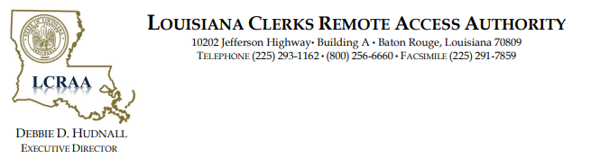

MEETING NOTICE
Louisiana Clerks Remote Access Authority (LCRAA)
Board of Commissioners Meeting
November 20, 2025
12:30 pm
Clerks Association Building
10202 Jefferson Hwy.
Building A
Baton Rouge, LA 70809
Please visit www.laclerksofcourt.org for additional information.

